**GOVERNMENT ARTS AND SCIENCE COLLEGE- SANKARANKOVIL**

**TENKASI DISTRICT**

APRIL - 2023

**Optimizing Flight Booking Decisions Through Machine Learning**

**Price Predictions-machine learning with python**

TEAM SIZE: 4

TEAM LEADER: Manojkumar.S – Reg no:20201361506114

TEAM MEMBERS:

1)Sasinthiran.G – Reg no:20201361506120

2)Abineshwaran.K –Reg no:20201361506101

3)Vignesh.C – Reg no:20201361506131

1. INTRODUCTION

* 1. overview

Flight ticket booking is the process of selecting and purchasing a ticket to travel on an airplane. The decision to book a flight ticket typically involves several factors, such as the purpose of travel, destination, budget, travel dates, and airline preferences. To make a flight ticket booking decision, individuals typically begin by researching flight options and comparing prices from different airlines. They may also consider factors such as flight duration, layover times, and in-flight amenities. Additionally, individuals may look for discounts or promotions that can help them save money on their ticket. Once a suitable flight option has been identified, individuals may proceed to book their ticket by providing their personal and payment information. It is important to carefully review the booking details before submitting the reservation to ensure that all information is correct. Overall, the decision to book a flight ticket requires careful consideration of various factors.

1.2 PURPOSE - THE USE OF THIS PROJECT

1.Convenience:

A flight ticket booking system allows travelers to search and book flights from thecomfort of their own home or office, saving them time and effort.

2.Cost savings:

By comp aring prices and flight options from different airlines, travelers can

find the best deals and save money on their travel expenses.

3.Flexibility:

Flight ticket booking systems often allow travelers to modify their bookings

such as changing their travel dates or adding extra services, providing more flexibility in their

travel plans.

4.Security:

Reputable flight ticket booking systems provide secure payment options,

protecting travelers' personal and financial information.

5.Accessibility:

Flight ticket booking systems provide travelers with information

about flight schedules, destinations, and airline policies, helping them make informed

decisions about their travel plans.

Proplem Definition & Design Thinking

2.1 Empathy map





An empathy map is a collaborative tool teams can use to gain a deeper insight into their customers. Much like a user persona, an empathy map can represent a group of users, such as a customer segment. The empathy map was originally created by Dave Gray and has gained much popularity within the agile community.

2.2 ideation & brainstorming map screenshot







Fig

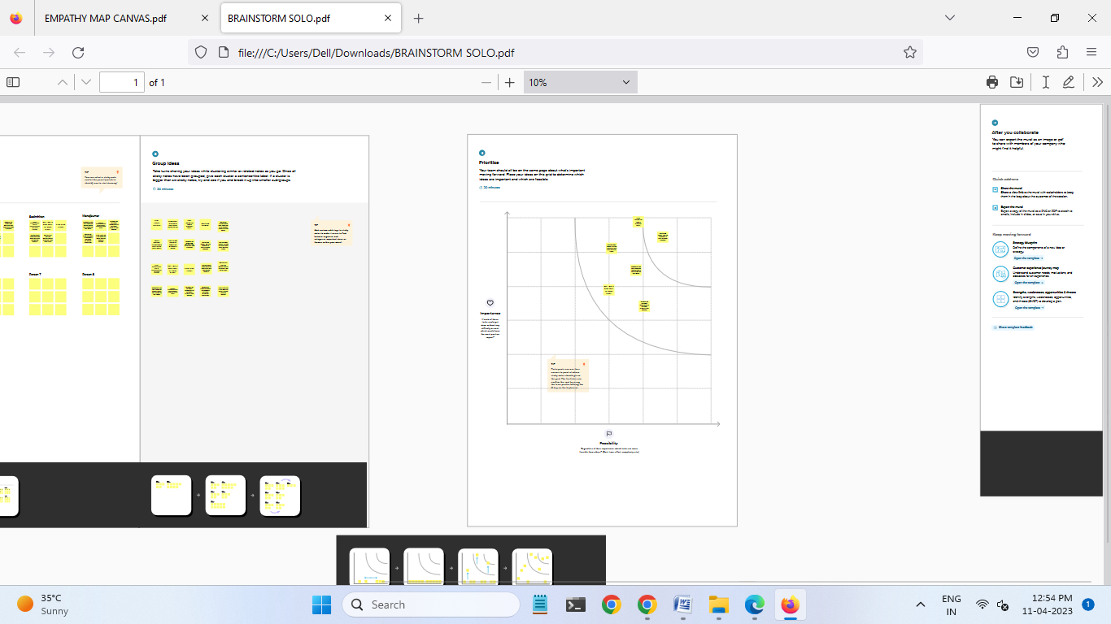

RESULT:

FINAL FINDINGS(OUTPUT) OF THE PROJECT ALONG WITH SCREENSHOTS

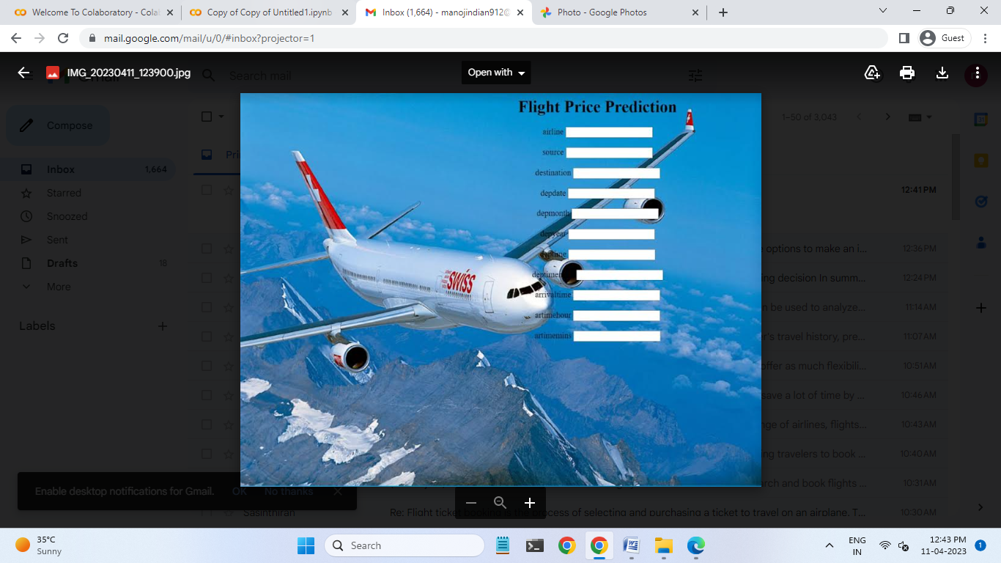

ADVANTAGES & DISADVANTAGES:

ADVANTAGES:

Convenience:

Booking flight tickets online is quick and easy, allowing travelers to book their tickets from anywhere at any time.

Cost-effective:

Online flight booking sites offer competitive prices, enabling travelers to compare prices from different airlines and choose the best option that suits their budget.

Time-saving:

Booking flight tickets online eliminates the need for travelers to visit travel agencies or airline offices, saving time and effort.

24/7 availability:

Online flight booking sites are available 24/7, allowing travelers to book their tickets at any time.

Access to information:

Online flight booking sites provide travelers with information about flight schedules, airline policies, and other travel-related information, helping them make informed decisions about their travel plans.

Variety:

Online flight booking systems provide access to a wide range of airlines, flights, and destinations, giving travelers more options to choose from.

User-friendly interface:

Flight ticket booking systems are designed to be user-friendly, making it easy for travelers to search for flights, compare prices, and make bookings.

Personalization:

A flight ticket booking decision system can use your past booking history and preferences to suggest flights that best suit your needs. For example, if you prefer direct flights or have a preferred airline, the system can suggest flights that match your preferences.

Easy cancellation and rescheduling:

A flight ticket booking decision system can make it easy to cancel or reschedule your flight if your plans change. The system can handle the entire process for you, which saves you time and effort.

Enhanced customer experience:

A flight ticket booking decision system can provide a seamless and hassle-free experience for customers, from the time they search for flights to the time they board the plane. This can help improve customer satisfaction and loyalty.

Disadvantages:

Technical issues:

Online flight booking sites can sometimes experience technical problems, such as website crashes, which can disrupt the booking process.

Hidden fees:

Some online flight booking sites may not disclose all fees upfront, leading to unexpected charges and additional expenses for travelers.

Lack of personalized service:

Online flight booking sites may not provide the personalized service and attention to detail that travelers may receive when booking flights through a travel agent.

Inflexibility:

Once flight tickets are booked online, they may be subject to strict cancellation and refund policies, limiting travelers' flexibility in changing their travel plans.

limited flexibility:

A flight ticket booking decision system may not offer as much flexibility as booking through a travel agent. For example, the system may not be able to accommodate special requests or changes to your itinerary as easily as a human travel agent can.

Information overload:

A flight ticket booking decision system can provide a lot of information about flights, prices, and routes, which can be overwhelming for some customers. This can make it difficult to make a decision and may lead to confusion or frustration.

Security concerns:

A flight ticket booking decision system may require customers to provide personal information such as credit card details, which can pose a security risk if the system is not properly secured. Customers may also be at risk of fraud or identity theft if their information is stolen.

Lack of customer support:

While a flight ticket booking decision system may offer 24/7 availability, it may not provide the same level of customer support as a human travel agent. This can make it difficult to get help if you have a problem or question that cannot be resolved through the system.

APPLICATIONS:

Personalized recommendations:

AI can be used to analyze the user's travel history, preferences, and behavior to suggest flight options that match their interests and needs.

Price prediction:

AI can be used to analyze historical flight pricing data and current market conditions to predict the best time to buy a ticket to get the best deal.

Flight delay prediction:

AI can be used to analyze weather data, flight schedules, and other factors to predict the likelihood of a flight being delayed.

Seat selection:

AI can be used to suggest the best seats based on the user's preferences, such as window or aisle seats, proximity to the restroom, etc.

Virtual travel assistant:

AI can be used to provide personalized travel advice, suggest attractions and activities at the destination, and answer any travel-related questions.

Fraud detection:

AI can be used to detect fraudulent activities in ticket booking, such as credit card fraud, fake bookings, etc.

Language translation:

AI can be used to provide language translation services to users who speak different languages, making it easier for them to book flights.

CONCLUSION:

Flight Booking Considerations. Flight Booking Conclusion summarizing of flight ticket booking decision In summary, booking a flight ticket requires careful consideration of various factors such as travel dates, destination, airline, price, and travel restrictions. It is essential to research and compare multiple options to find the best deal and ensure a smooth and comfortable travel experience. Additionally, it is important to review the airline's policies regarding cancellations, changes, and refunds in case of any unforeseen circumstances. By taking these factors into account, one can make an informed decision and book a flight ticket that meets their needs and budget.More Conclusion summariszing In conclusion, booking a flight ticket is a crucial part of travel planning that can have a significant impact on the overall travel experience. It involves considering several factors, such as travel dates, destination, airline, price, and policies, to find the best option that fits. the traveler's needs and budget. It is essential to research and compare multiple options to make an informed decision and ensure a comfortable and hassle-free journey. Additionally, travelers should be aware of any travel restrictions or entry requirements that may affect their travel plans. By taking these factors into account and making a well-informed decision, travelers can book a flight ticket with confidence and enjoy a successful trip.

FUTURE SCOPE:

Artificial intelligence (AI) and machine learning (ML):

AI and ML can be used to analyze data and provide personalized recommendations to travelers, such as suggesting the best time to book flights, the cheapest routes, and preferred airlines.

Virtual and augmented reality (VR/AR):

VR and AR technologies can be used to provide travelers with immersive experiences of their travel destinations, helping them make informed decisions about their travel plans.

Mobile apps:

Mobile apps can provide travelers with real-time updates about their flights, such as gate changes, delays, and cancellations, providing more flexibility and convenience.

Blockchain technology:

Blockchain technology can be used to enhance the security and transparency of flight ticket bookings, providing travelers with more confidence in the booking process.

Sustainability initiatives:

Flight ticket booking systems can integrate sustainability initiatives, such as carbon offset programs, to provide travelers with more environmentally-friendly travel options.

Overall, the future scope of flight ticket booking decision system is exciting, with several potential developments that can improve the booking process for travelers and provide a more seamless travel experience.

SOURCE CODE:

import pandas as pd

import numpy as np

from pandas._libs import sparse

import matplotlib.pyplot as plt

import seaborn as sns

from sklearn. model_selection import train_test_split

from sklearn.ensemble import RandomForestClassifier,GradientBoostingClassifier

from sklearn.tree import DecisionTreeClassifier

from sklearn.neighbors import KNeighborsClassifier

from sklearn.metrics import f1_score

from sklearn.metrics import classification_report,confusion_matrix

import warnings

from scipy import stats

warnings.filterwarnings('ignore')

plt.style.use('fivethirtyeight')

from sklearn.datasets import load_breast_cancer

iris=load_iris() x=iris.data

y=iris.target

from sklearn.neighbors import KNeighborsClassifier knn = KNeighborsClassifier(n_neighbors = 1)

from google.colab import files ubloaded=files.upload()

No file chosen Upload widget is only available when the cell has been executed in the current browser session. Please rerun this cell to

Choose Files

enable.

Saving Data Train csv to Data Train (1) csv

data=pd.read_csv("Data_Train.csv") data.head()

# Airline Date_of_Journey Source Destination Route Dep_Time Arrival_Time Duration Total_Stops Additional_Info Price

1. IndiGo 24/03/2019 Banglore New Delhi BLR →

DEL

CCU →

22:20 01:10 22 Mar 2h 50m non-stop No info 3897

1. Air India 1/05/2019 Kolkata Banglore

IXR → BBI → BLR

05:50 13:15 7h 25m 2 stops No info 7662

Jet

DEL → LKO →

category = ['Airline','Source','Price','Destination','Additional_Info','Dep_Time'] for i in category:

print(i,data[i].unique())

Airline ['IndiGo' 'Air India' 'Jet Airways' 'SpiceJet' 'Multiple carriers' 'GoAir' 'Vistara' 'Air Asia' 'Vistara Premium economy' 'Jet Airways Business'

'Multiple carriers Premium conomy' 'Trujet'Source ['Banglore' 'Kolkata' 'Delhi' 'Chennai' 'Mumbai'] Price [ 3897 7662 13882 ... 9790 12352 12648]

Destination ['New Delhi' 'Banglore' 'Cochin' 'Kolkata' 'Delhi' 'Hyderabad']

Additional_Info ['No info' 'In-flight meal not included' 'No check-in baggage included' '1 Short layover' 'No Info' '1 Long layover' 'Change airports'

'Business class' 'Red-eye flight' '2 Long layover']

Dep_Time ['22:20' '05:50' '09:25' '18:05' '16:50' '09:00' '18:55' '08:00' '08:55'

'11:25' '09:45' '20:20' '11:40' '21:10' '17:15' '16:40' '08:45' '14:00'

'20:15' '16:00' '14:10' '22:00' '04:00' '21:25' '21:50' '07:00' '07:05'

'09:50' '14:35' '10:35' '15:05' '14:15' '06:45' '20:55' '11:10' '05:45'

'19:00' '23:05' '11:00' '09:35' '21:15' '23:55' '19:45' '08:50' '15:40'

'06:05' '15:00' '13:55' '05:55' '13:20' '05:05' '06:25' '17:30' '08:20'

'19:55' '06:30' '14:05' '02:00' '09:40' '08:25' '20:25' '13:15' '02:15'

'16:55' '20:45' '05:15' '19:50' '20:00' '06:10' '19:30' '04:45' '12:55'

'18:15' '17:20' '15:25' '23:00' '12:00' '14:45' '11:50' '11:30' '14:40'

'19:10' '06:00' '23:30' '07:35' '13:05' '12:30' '15:10' '12:50' '18:25'

'16:30' '00:40' '06:50' '13:00' '19:15' '01:30' '17:00' '10:00' '19:35'

'15:30' '12:10' '16:10' '20:35' '22:25' '21:05' '05:35' '05:10' '06:40'

'15:15' '00:30' '08:30' '07:10' '05:30' '14:25' '05:25' '10:20' '17:45'

'13:10' '22:10' '04:55' '17:50' '21:20' '06:20' '15:55' '20:30' '17:25'

'09:30' '07:30' '02:35' '10:55' '17:10' '09:10' '18:45' '15:20' '22:50'

'14:55' '14:20' '13:25' '22:15' '11:05' '16:15' '20:10' '06:55' '19:05'

'07:55' '07:45' '10:10' '08:15' '11:35' '21:00' '17:55' '16:45' '18:20'

'03:50' '08:35' '19:20' '20:05' '17:40' '04:40' '17:35' '09:55' '05:00'

'18:00' '02:55' '20:40' '22:55' '22:40' '21:30' '08:10' '17:05' '07:25'

'15:45' '09:15' '15:50' '11:45' '22:05' '18:35' '00:25' '19:40' '20:50'

'22:45' '10:30' '23:25' '11:55' '10:45' '11:15' '12:20' '14:30' '07:15'

'01:35' '18:40' '09:20' '21:55' '13:50' '01:40' '00:20' '04:15' '13:45'

'18:30' '06:15' '02:05' '12:15' '13:30' '06:35' '10:05' '08:40' '03:05'

'21:35' '16:35' '02:30' '16:25' '05:40' '15:35' '13:40' '07:20' '04:50'

'12:45' '10:25' '12:05' '11:20' '21:40' '03:00']

data.Date_of_Journey=data.Date_of_Journey.str.split('/')

data.Date_of_Journey

|  |  |
| --- | --- |
| 0 | [24, 03, 2019] |
| 1 | [1, 05, 2019] |
| 2 | [9, 06, 2019] |
| 3 | [12, 05, 2019] |
| 4 | [01, 03, 2019] |
| 10678 | ...  [9, 04, 2019] |
| 10679 | [27, 04, 2019] |
| 10680 | [27, 04, 2019] |
| 10681 | [01, 03, 2019] |
| 10682 | [9, 05, 2019] |

Name: Date_of_Journey, Length: 10683, dtype: object

data['Date']=data.Date_of_Journey.str[0] data['Month']=data.Date_of_Journey.str[1] data['Year']=data.Date_of_Journey.str[2]

data.Total_Stops.unique()

array(['non-stop', '2 stops', '1 stop', '3 stops', nan, '4 stops'], dtype=object)

data.Route.str.split('@') data.Route

1. BLR → DEL
2. CCU → IXR → BBI → BLR
3. DEL → LKO → BOM → COK
4. CCU → NAG → BLR
5. BLR → NAG → DEL

...

|  |  |
| --- | --- |
| 10678 | CCU → BLR |
| 10679 | CCU → BLR |
| 10680 | BLR → DEL |
| 10681 | BLR → DEL |
| 10682 | DEL → GOI → BOM → COK |

Name: Route, Length: 10683, dtype: object

data['city1']=data.Rte.str[0] data['city2']=datastr[1] data['city3']=data.Route.str[2] data['city4']=data.Route.str[3] data['city5']=data.Route.str[4] data['city6']=data.Route.str[5]

data["Price"]

|  |  |
| --- | --- |
| 0 | 3897 |
| 1 | 7662 |
| 2 | 13882 |
| 3 | 6218 |
| 4 | 13302 |
| 10678 | ...  4107 |
| 10679 | 4145 |
| 10680 | 7229 |
| 10681 | 12648 |
| 10682 | 11753 |

Name: Price, Length: 10683, dtype: int64

my_data={'Dep_Time'}

data["Dep_Time"]

0 22:20

1 05:50

2 09:25

3 18:05

4 16:50

...

10678 19:55

10679 20:45

10680 08:20

10681 11:30

10682 10:55

Name: Dep_Time, Length: 10683, dtype: object

data.Dep_Time=data.Dep_Time.str.split(':')

data['Dep_Time_Hour'] = data.Dep_Time.str[0] data['Dep_Time_Hour'] = data.Dep_Time.str[1]

data.Arrival_Time=data.Arrival_Time.str.split(' ')

data['Arrival_date']=data.Arrival_Time.str[1]

data['Time_of_Arrival']=data.Arrival_Time.str[0]

data['Time_of_Arrival']=data.Time_of_Arrival.str.split(':')

data['Arrival_Time_Hour']=data.Time_of_Arrival.str[0] data['Arrival_Time_Mins']=data.Time_of_Arrival.str[1]

data.Duration=data.Duration.str.split(' ')

data['Travel_Hours']=data.Duration.str[0]

data['Travel_Hours']=data['Travel_Hours'].str.split('h') data['Travel_Hours']=data['Travel_Hours'].str[0]

data.Travel_Hours=data.Travel_Hours

data['Travel_Mins']=data.Duration.str[1]

data.Travel_Mins=data.Travel_Mins.str.split('m') data.Travel_Mins=data.Travel_Mins.str[0]

data.Total_Stops.replace('non_stop',0,inplace=True) data.Total_Stops=data.Total_Stops.str.split(':')

data.Total_Stops=data.Total_Stops.str[0]

data.Total_Stops.replace('non_stop',0,inplace=True) data.Total_Stops=data.Total_Stops.str.split(' ')

data.Total_Stops=data.Total_Stops.str[0]

data.Additional_Info.unique()

array(['No info', 'In-flight meal not included',

'No check-in baggage included', '1 Short layover', 'No Info', '1 Long layover', 'Change airports', 'Business class',

'Red-eye flight', '2 Long layover'], dtype=object)

data.Additional_Info.replace('No Info','No info',inplace=True)

data.isnull().sum()

|  |  |
| --- | --- |
| Airline | 0 |
| Date_of_Journey | 0 |
| Source | 0 |
| Destination | 0 |
| Route | 1 |
| Dep_Time | 0 |
| Arrival_Time | 0 |
| Duration | 0 |
| Total_Stops | 1 |
| Additional_Info | 0 |
| Price | 0 |
| Date | 0 |
| Month | 0 |
| Year | 0 |
| city1 | 1 |
| city2 | 1 |
| city3 | 1 |
| city4 | 1 |
| city5 | 1 |
| city6 | 1 |
| Dep_Time_Hour | 0 |
| Arrival_date | 10683 |
| Time_of_Arrival | 0 |
| Arrival_Time_Hour | 0 |
| Arrival_Time_Mins | 0 |
| Travel_Hours | 0 |
| Travel_Mins | 1032 |
| dtype: int64 |  |

data.drop(['city4','city5','city6'], axis=1, inplace=True)

data.drop(['Date_of_Journey','Route','Dep_Time','Duration'],axis=1, inplace=True)

data.drop(['Time_of_Arrival'],axis=1,inplace=True)

data.isnull().sum()

|  |  |
| --- | --- |
| Airline | 0 |
| Source | 0 |
| Destination | 0 |
| Arrival_Time | 0 |
| Total_Stops | 1 |
| Additional_Info | 0 |
| Price | 0 |
| Date | 0 |
| Month | 0 |
| Year | 0 |
| city1 | 1 |
| city2 | 1 |
| city3 | 1 |
| Dep_Time_Hour | 0 |
| Arrival_date | 10683 |
| Arrival_Time_Hour | 0 |
| Arrival_Time_Mins | 0 |
| Travel_Hours | 0 |
| Travel_Mins  dtype: int64 | 1032 |

data['city3'].fillna('None',inplace=True)

data['Arrival_date'].fillna(data['Date'],inplace=True)

data['Travel_Mins'].fillna(0,inplace=True)

data.info()

<class 'pandas.core.frame.DataFrame'> RangeIndex: 10683 entries, 0 to 10682 Data columns (total 19 columns):

|  |  |  |  |  |  |
| --- | --- | --- | --- | --- | --- |
| # |  | Column | Non-Null Count |  | Dtype |
| 0 |  | Airline | 10683 non-null |  | object |
| 1 |  | Source | 10683 non-null |  | object |
| 2 |  | Destination | 10683 non-null |  | object |
| 3 |  | Arrival_Time | 10683 non-null |  | object |
| 4 |  | Total_Stops | 10682 non-null |  | object |
| 5 |  | Additional_Info | 10683 non-null |  | object |
| 6 |  | Price | 10683 non-null |  | int64 |
| 7 |  | Date | 10683 non-null |  | object |

|  |  |  |  |
| --- | --- | --- | --- |
| 8 | Month | 10683 non-null | object |
| 9 | Year | 10683 non-null | object |
| 10 | city1 | 10682 non-null | object |
| 11 | city2 | 10682 non-null | object |
| 12 | city3 | 10683 non-null | object |
| 13 | Dep_Time_Hour | 10683 non-null | object |
| 14 | Arrival_date | 0 non-null | float64 |
| 15 | Arrival_Time_Hour | 10683 non-null | object |
| 16 | Arrival_Time_Mins | 10683 non-null | object |
| 17 | Travel_Hours | 10683 non-null | object |
| 18 | Travel_Mins | 10683 non-null | object |

dtypes: float64(1), int64(1), object(17) memory usage: 1.5+ MB

data.Travel_Mins=data.Travel_Mins.astype('int64')

data.Date=data.Date.astype('int64')

data.Month=data.Month.astype('int64') data.Year=data.Year.astype('int64')

data.Dep_Time_Hour=data.Dep_Time_Hour.astype('int64') data.Dep_Time_Hour=data.Dep_Time_Hour.astype('int64')

data.Arrival_Time_Hour=data.Arrival_Time_Hour.astype('int64') data.Arrival_Time_Mins=data.Arrival_Time_Mins.astype('int64')

data[data['Travel_Hours']=='5m']

# Airline Source Destination Arrival_Time Total_Stops Additional_Info Price Date Month Year city1 city2 city3 Dep_T

**6474** Air India Mumbai Hyderabad [16:55] 2 stops No info 17327 6 3 2019 B O M

data.drop(index=6474,inplace=True,axis=0)

data.Travel_Hours=data.Travel_Hours.astype('int64')

categorical=['Airline','Source','Destination','Additional_Info','City1','Price']

numerical=['Total_stops','Date','Month','Year','Dep_Time_Hour','Dep_Time_Mins','Arrival_date','Arrival_Time_Hour','Arrival_Time_Mins','Tr

from sklearn.preprocessing import LabelEncoder le=LabelEncoder()

data.Airline=le.fit_transform(data.Airline) data.source=le.fit_transform(data.Source)

data.Destination=le.fit_transform(data.Destination) data.Total_Stops=le.fit_transform(data.Total_Stops) data.cityt1=le.fit_transform(data.city1)

data.city2=le.fit_transform(data.city2) data.city3=le.fit_transform(data.city3)

data.Additional_Info=le.fit_transform(data.Additional_Info) data.head()

|  |  |  |  |  |  |  |  |  |  |  |  |  |  |
| --- | --- | --- | --- | --- | --- | --- | --- | --- | --- | --- | --- | --- | --- |
| **Airline** | **Source** | **Destination** | **Arrival_Time** | **Total_Stops** | **Additional_Info** | **Price** | **Date** | **Month** | **Year** | **city1** | **city2** | **city3** | **Dep_Tim** |
| **0** 3 | Banglore | 5 | [01:10 22 Mar] | 4 | 7 | 3897 | 24 | 3 | 2019 | B | 3 | 4 |  |
| **1** 1 | Kolkata | 0 | [13:15] | 1 | 7 | 7662 | 1 | 5 | 2019 | C | 1 | 5 |  |
| **2** 4 | Delhi | 1 | [04:25 10 Jun] | 1 | 7 | 13882 | 9 | 6 | 2019 | D | 2 | 1 |  |
| **3** 3 | Kolkata | 0 | [23:30] | 0 | 7 | 6218 | 12 | 5 | 2019 | C | 1 | 5 |  |
| **4** 3 | Banglore | 5 | [21:35] | 0 | 7 | 13302 | 1 | 3 | 2019 | B | 3 | 4 |  |

data.head()

|  |  |  |  |  |  |  |  |  |  |  |  |  |  |
| --- | --- | --- | --- | --- | --- | --- | --- | --- | --- | --- | --- | --- | --- |
| **Airline** | **Source** | **Destination** | **Arrival_Time** | **Total_Stops** | **Additional_Info** | **Price** | **Date** | **Month** | **Year** | **city1** | **city2** | **city3** | **Dep_Tim** |
| **0** 3 | Banglore | 5 | [01:10 22 Mar] | 4 | 7 | 3897 | 24 | 3 | 2019 | B | 3 | 4 |  |
| **1** 1 | Kolkata | 0 | [13:15] | 1 | 7 | 7662 | 1 | 5 | 2019 | C | 1 | 5 |  |
| **2** 4 | Delhi | 1 | [04:25 10 Jun] | 1 | 7 | 13882 | 9 | 6 | 2019 | D | 2 | 1 |  |
| **3** 3 | Kolkata | 0 | [23:30] | 0 | 7 | 6218 | 12 | 5 | 2019 | C | 1 | 5 |  |
| **4** 3 | Banglore | 5 | [21:35] | 0 | 7 | 13302 | 1 | 3 | 2019 | B | 3 | 4 |  |

data=data[['Airline','Source','Destination','Date','Month','Year','Dep_Time_Hour','Arrival_Time_Mins','Arrival_Time']]

data.head()

|  |  |  |  |  |  |  |  |  |
| --- | --- | --- | --- | --- | --- | --- | --- | --- |
| **Airline** | **Source** | **Destination** | **Date** | **Month** | **Year** | **Dep_Time_Hour** | **Arrival_Time_Mins** | **Arrival_Time** |
| **0** 3 | Banglore | 5 | 24 | 3 | 2019 | 20 | 10 22 Mar | [01:10 22 Mar] |
| **1** 1 | Kolkata | 0 | 1 | 5 | 2019 | 50 | 15 | [13:15] |
| **2** 4 | Delhi | 1 | 9 | 6 | 2019 | 25 | 25 10 Jun | [04:25 10 Jun] |
| **3** 3 | Kolkata | 0 | 12 | 5 | 2019 | 5 | 30 | [23:30] |
| **4** 3 | Banglore | 5 | 1 | 3 | 2019 | 50 | 35 | [21:35] |

|  |  |  |  |  |  |
| --- | --- | --- | --- | --- | --- |
| data.describe()  **Airline** | **Destination** | **Date** | **Month** | **Year** | **Dep_Time_Hour** |
| **count** 10682.000000 | 10682.000000 | 10682.000000 | 10682.000000 | 10682.0 | 10682.000000 |
| **mean** 3.966205 | 1.435967 | 13.509081 | 4.708762 | 2019.0 | 24.408819 |
| **std** 2.352090 | 1.474773 | 8.479363 | 1.164294 | 0.0 | 18.767225 |
| **min** 0.000000 | 0.000000 | 1.000000 | 3.000000 | 2019.0 | 0.000000 |
| **25%** 3.000000 | 0.000000 | 6.000000 | 3.000000 | 2019.0 | 5.000000 |
| **50%** 4.000000 | 1.000000 | 12.000000 | 5.000000 | 2019.0 | 25.000000 |
| **75%** 4.000000 | 2.000000 | 21.000000 | 6.000000 | 2019.0 | 40.000000 |
| **max** 11.000000 | 5.000000 | 27.000000 | 6.000000 | 2019.0 | 55.000000 |

import seaborn as sns c=1

plt.figure(figsize=(20,45))

<Figure size 2000x4500 with 0 Axes>

<Figure size 2000x4500 with 0 Axes>

for i in categorical:

plt.subplot(6,3,c)

sns.countplot(data[i]) plt.xticks(rotation=90)

plt.tight_layout(pad=3.0) c=c+1

plt.show()

from sklearn.datasets import load_iris

iris=load_iris()

df=pd.DataFrame(iris.data,columns=iris.feature_names)

price_list=pd.DataFrame({'price:prices'})

price_list

# 0

**0** price:prices

Price

sns.displot(data.Price)

Final output:

Webframe work



<seaborn.axisgrid.FacetGrid at 0x7fd58ceddc10>

plt.figure(figsize=(15,8)) sns.displot(data.Price)

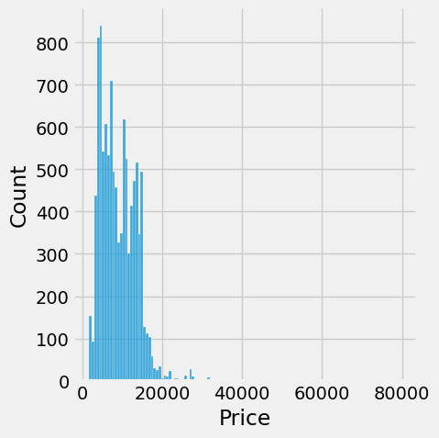

sns.heatmap(data.corr(),annot=True)

<Axes: >

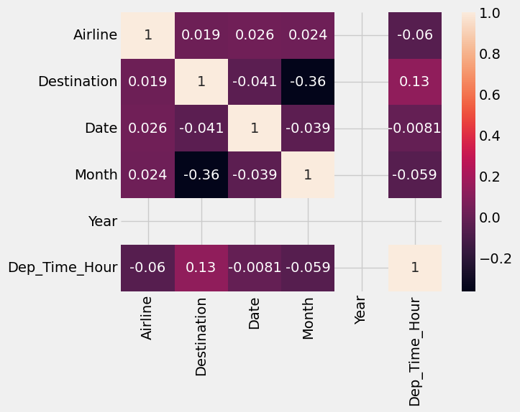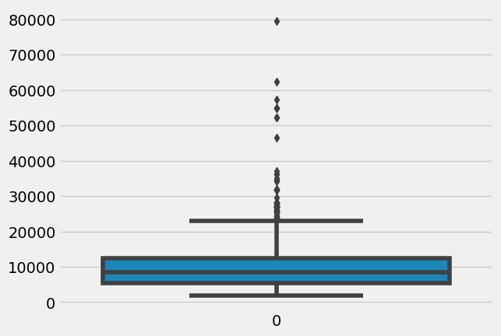

import seaborn as sns

sns.boxplot(data['Price'])

<Axes: >

y = data['Price']

x = data.drop(columns=['Price'],axis=1)

from sklearn.preprocessing import StandardScaler scaler=StandardScaler()

knn.fit(x,y)



▾

KNeighborsClassifier

KNeighborsClassifier(n_neighbors=1)

print(x_scaled)

[[-9.00681170e-01 1.01900435e+00 -1.34022653e+00 -1.31544430e+00] [-1.14301691e+00 -1.31979479e-01 -1.34022653e+00 -1.31544430e+00] [-1.38535265e+00 3.28414053e-01 -1.39706395e+00 -1.31544430e+00] [-1.50652052e+00 9.82172869e-02 -1.28338910e+00 -1.31544430e+00] [-1.02184904e+00 1.24920112e+00 -1.34022653e+00 -1.31544430e+00] [-5.37177559e-01 1.93979142e+00 -1.16971425e+00 -1.05217993e+00] [-1.50652052e+00 7.88807586e-01 -1.34022653e+00 -1.18381211e+00] [-1.02184904e+00 7.88807586e-01 -1.28338910e+00 -1.31544430e+00] [-1.74885626e+00 -3.62176246e-01 -1.34022653e+00 -1.31544430e+00] [-1.14301691e+00 9.82172869e-02 -1.28338910e+00 -1.44707648e+00] [-5.37177559e-01 1.47939788e+00 -1.28338910e+00 -1.31544430e+00] [-1.26418478e+00 7.88807586e-01 -1.22655167e+00 -1.31544430e+00] [-1.26418478e+00 -1.31979479e-01 -1.34022653e+00 -1.44707648e+00] [-1.87002413e+00 -1.31979479e-01 -1.51073881e+00 -1.44707648e+00] [-5.25060772e-02 2.16998818e+00 -1.45390138e+00 -1.31544430e+00] [-1.73673948e-01 3.09077525e+00 -1.28338910e+00 -1.05217993e+00] [-5.37177559e-01 1.93979142e+00 -1.39706395e+00 -1.05217993e+00] [-9.00681170e-01 1.01900435e+00 -1.34022653e+00 -1.18381211e+00] [-1.73673948e-01 1.70959465e+00 -1.16971425e+00 -1.18381211e+00] [-9.00681170e-01 1.70959465e+00 -1.28338910e+00 -1.18381211e+00] [-5.37177559e-01 7.88807586e-01 -1.16971425e+00 -1.31544430e+00] [-9.00681170e-01 1.47939788e+00 -1.28338910e+00 -1.05217993e+00] [-1.50652052e+00 1.24920112e+00 -1.56757623e+00 -1.31544430e+00] [-9.00681170e-01 5.58610819e-01 -1.16971425e+00 -9.20547742e-01] [-1.26418478e+00 7.88807586e-01 -1.05603939e+00 -1.31544430e+00] [-1.02184904e+00 -1.31979479e-01 -1.22655167e+00 -1.31544430e+00] [-1.02184904e+00 7.88807586e-01 -1.22655167e+00 -1.05217993e+00] [-7.79513300e-01 1.01900435e+00 -1.28338910e+00 -1.31544430e+00] [-7.79513300e-01 7.88807586e-01 -1.34022653e+00 -1.31544430e+00] [-1.38535265e+00 3.28414053e-01 -1.22655167e+00 -1.31544430e+00] [-1.26418478e+00 9.82172869e-02 -1.22655167e+00 -1.31544430e+00] [-5.37177559e-01 7.88807586e-01 -1.28338910e+00 -1.05217993e+00]



[-7.79513300e-01 2.40018495e+00 -1.28338910e+00 -1.44707648e+00] [-4.16009689e-01 2.63038172e+00 -1.34022653e+00 -1.31544430e+00] [-1.14301691e+00 9.82172869e-02 -1.28338910e+00 -1.31544430e+00] [-1.02184904e+00 3.28414053e-01 -1.45390138e+00 -1.31544430e+00] [-4.16009689e-01 1.01900435e+00 -1.39706395e+00 -1.31544430e+00] [-1.14301691e+00 1.24920112e+00 -1.34022653e+00 -1.44707648e+00] [-1.74885626e+00 -1.31979479e-01 -1.39706395e+00 -1.31544430e+00] [-9.00681170e-01 7.88807586e-01 -1.28338910e+00 -1.31544430e+00] [-1.02184904e+00 1.01900435e+00 -1.39706395e+00 -1.18381211e+00] [-1.62768839e+00 -1.74335684e+00 -1.39706395e+00 -1.18381211e+00] [-1.74885626e+00 3.28414053e-01 -1.39706395e+00 -1.31544430e+00] [-1.02184904e+00 1.01900435e+00 -1.22655167e+00 -7.88915558e-01] [-9.00681170e-01 1.70959465e+00 -1.05603939e+00 -1.05217993e+00] [-1.26418478e+00 -1.31979479e-01 -1.34022653e+00 -1.18381211e+00] [-9.00681170e-01 1.70959465e+00 -1.22655167e+00 -1.31544430e+00] [-1.50652052e+00 3.28414053e-01 -1.34022653e+00 -1.31544430e+00] [-6.58345429e-01 1.47939788e+00 -1.28338910e+00 -1.31544430e+00] [-1.02184904e+00 5.58610819e-01 -1.34022653e+00 -1.31544430e+00] [ 1.40150837e+00 3.28414053e-01 5.35408562e-01 2.64141916e-01] [ 6.74501145e-01 3.28414053e-01 4.21733708e-01 3.95774101e-01] [ 1.28034050e+00 9.82172869e-02 6.49083415e-01 3.95774101e-01] [-4.16009689e-01 -1.74335684e+00 1.37546573e-01 1.32509732e-01] [ 7.95669016e-01 -5.92373012e-01 4.78571135e-01 3.95774101e-01] [-1.73673948e-01 -5.92373012e-01 4.21733708e-01 1.32509732e-01] [ 5.53333275e-01 5.58610819e-01 5.35408562e-01 5.27406285e-01] [-1.14301691e+00 -1.51316008e+00 -2.60315415e-01 -2.62386821e-01]



x_scaled = scaler.fit_transform(x)

x_scaled = pd.DataFrame(x_scaled,columns=x.columns) x_scaled.head()

scaler = StandardScaler()

x_scaled = scaler.fit_transform(x)

from sklearn.model_selection import train_test_split

x_train,x_test,y_train,y_test=train_test_split(x,y,test_size=0.2,random_state=42)

x_train.head()

# Airline Date_of_Journey Source Destination Route Dep_Time Arrival_Time Duration Total_Stops Additional_Info

**8990**

Jet 12/03/2019 Mumbai Hyderabad Airways

Jet

BOM → VNS → DEL

→ HYD

DEL →

06:30 16:35 10h 5m 2 stops No info

In-flight meal not

# 3684

Airways 9/05/2019 Delhi Cochin

BOM → COK

11:30 12:35 10 May 25h 5m 1 stop

included

**1034** SpiceJet 24/04/2019 Delhi Cochin

DEL →

MAA → 15:45 22:05 6h 20m 1 stop

No info

from sklearn.ensemble import AdaBoostRegressor

rfr = RandomForestRegressor()

gb = GradientBoostingRegressor()

ad = AdaBoostRegressor()

from sklearn.ensemble import RandomForestRegressor, GradientBoostingRegressor, AdaBoostRegressor rfr=RandomForestRegressor()

gb=GradientBoostingRegressor() ad=AdaBoostRegressor()

from sklearn.metrics import r2_score,mean_absolute_error,mean_squared_error for i in [rfr,gb,ad]:

i.fit(x_train,y_train)

y_pred=i.predict(x_test)

test_score=r2_score(y_test,y_pred)

train_score=r2_score(y_train, i.predict(x_train)) if abs(train_score-test_score)<=0.2:

print(i)

print("R2 score is",r2_score(y_test,y_pred))

print("r2 for train data",r2_score(y_train, i.predict(x_train)))

print("Mean Absolute Error is",mean_absolute_error(y_pred,y_test)) print("Mean Squred Error is",mean_squared_error(y_pred,y_test))

print("Root Mean Squared Error is", (mean_squared_error(y_pred,y_test,squared=False)))

from sklearn.neighbors import KNeighborsRegressor from sklearn.svm import SVR

from sklearn.tree import DecisionTreeRegressor

from sklearn.metrics import r2_score,mean_absolute_error,mean_squared_error

knn=KNeighborsRegressor() svr=SVR()

dt=DecisionTreeRegressor()

for i in [knn,svr,dt]:

i.fit(x_train,y_train)

y_pred=i.predict(x_test)

test_score=r2_score(y_test,y_pred)

train_score=r2_score(y_train,i.predict(x_train)) if abs(train_score-test_score)<=0.1:

print(i)

print('R2 score is',r2_score(y_test,y_pred))

print("R2 for train data",r2_score(y_train, i.predict(x_train)))

print('Mean Absolute Error is',mean_absolute_error(y_pred,y_test)) print('Mean Squred Error is',mean_squared_error(y_pred,y_test))

print('Root Mean Squared Error is', (mean_squared_error(y_pred,y_test,squared=False)))

from sklearn.model_selection import cross_val_score for i in range(2,5):

cv=cross_val_score(rfr,x,y,cv=i) print(rfr,cv.mean())

RandomForestRegressor(max_features='sqrt', n_estimators=10) -2.0431999999999997

RandomForestRegressor(max_features='sqrt', n_estimators=10) 0.0

RandomForestRegressor(max_features='sqrt', n_estimators=10) 0.38848557692307695

from sklearn.model_selection import RandomizedSearchCV

param_grid={'n_estimators':[10,30,50,70,100],'max_depth':[None,1,2,3], 'max_features':['auto','sqrt']}

rfr=RandomForestRegressor()

rf_res=RandomizedSearchCV(estimator=rfr,param_distributions=param_grid,cv=3,verbose=2,n_jobs=-1) rf_res.fit(x_train,y_train)

gb=GradientBoostingRegressor()

gb_res=RandomizedSearchCV(estimator=gb,param_distributions=param_grid,cv=3,verbose=2,n_jobs=-1) gb_res.fit(x_train,y_train)

rfr=RandomForestRegressor(n_estimators=10,max_features='sqrt',max_depth=None) rfr.fit(x_train,y_train)

y_train_pred=rfr.predict(x_train) y_test_pred=rfr.predict(x_test)

print("train accuracy",r2_score(y_train_pred,y_train)) print("test accuracy",r2_score(y_test_Pred,y_test))

price_list=pd.DataFrame({'price:prices'})

price_list

# 0

**0** price:prices

import pickle

pickle.dump(rfr,open('model1.pkl','wb'))

import pickle

pickle.dump(rfr,open('model1.pkl','wb'))